**First 2D & 3D BIM CAD Product configurator for smoke ventilation and fire safety systems**

„By reducing similar requests, Souchier can focus on complex cases.“

**Augsburg, Germany, 24th February 2016.** In order to provide suitable 2D and 3D CAD BIM information and to save its customers time in addition, the company Souchier in France relies on the Interactive Product Configurator of the eCATALOGsolutions Technology by CADENAS. Thus, this is the first 2D & 3D BIM CAD Product Configurator for smoke ventilation and fire safety systems. Compared to other suppliers of smoke ventilation solutions the configurator allows to get competitive edge.

**Immense time saving due to reduced number of questions**

In the company seven employees working in the design department and facing a multitude of inquiries, e. g. project support. Customers request information, technical data as well as 3D BIM CAD models of products.

„The goal was to save time on both sides. With the configurator, the customer gets the response to his question immediately, while Souchier can concentrate on the more difficult cases due to the reduced amount of inquiries“, explaines David Maillart, Manager research and development at Souchier.

Products of Souchier do not have predefined standard dimensions, Instead, they are individually customized. CADENAS’ Product Configurator aims at providing customers with a complete product configuration, precisely down to the millimeter, including motorization and possible versions, while at the same time reducing the workload of the design department.

**Advantages of the configurator - service for customers**

The Produkt Configurator shows a 3D view of the integratebale configured system of Souchier in all construction or renovation projects. All needed data like parameters etc. can be entered. The user friendly interface and the intuitive navigation take the user step by step to the desired configuration; configuration errors will be avoided.

On the screen, different kinds of views are available to the user, like a 2D view, a 3D view, an exploded view and many more. All relevant data sheets can also be generated and downloaded as PDF data sheet.

Since the introduction of the Online Configurator already five products are currently available: Airlam V2 (ventilation screens for fresh air supply from the external facade), Exubaie and Exubaie V2 (single wing smoke and heat ventilation for the facade), Certilight (naturally looking, two-winged smoke and heat extraction system for roof surfaces) and Ventilight (naturally looking, single winged smoke and heat ventilation system for roof surfaces).

For more Information, please read the success story of Souchier and CADENAS:  
[www.cadenas.de/ecatalogssolutions/success-stories](http://www.cadenas.de/tl_files/cadenas/Downloads/PDF/Referenzen/EN/eCATALOGsolutions_SOUCHIER_Success_Story_EN.pdf)

**Press Images:**

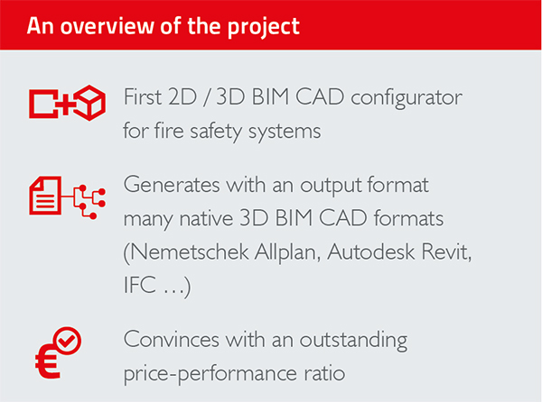

**Caption 1:** With the Interactive Product Configurator of eCATALOGsolutions technology by CADENAS Souchier has the first 2D / 3D BIM CAD configurator for smoke control and fire protection systems.

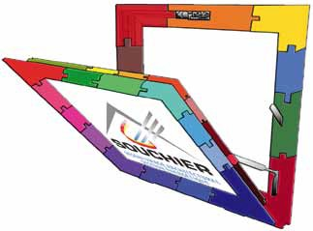

**Caption 2:** The 2D / 3D BIM CAD Configurator analyzed and verified the compatibility of the selected items and instantly shows a 3D view of the configured system.

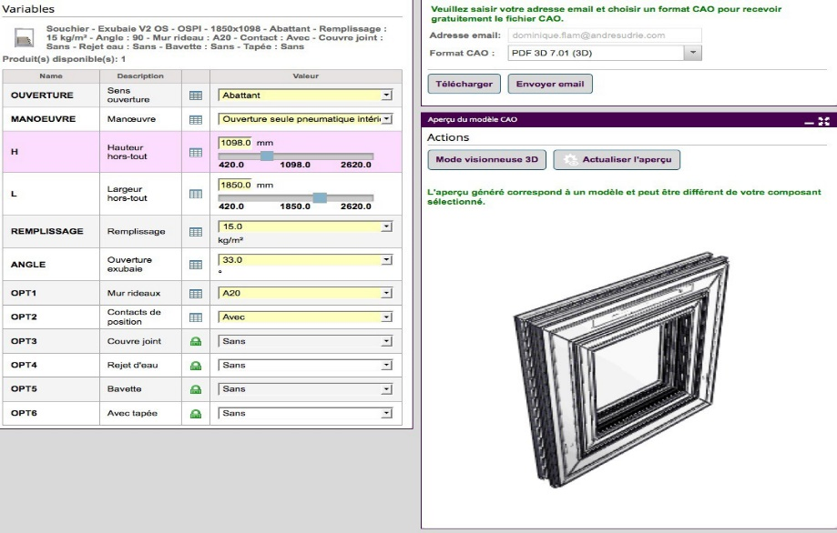

**Caption 3:** The product configurator enables real 3D visualization of integrable ventilation products Souchier in all building and renovation projects.

This press release and accompanying images are available for download from our website: [www.cadenas.de/press/press-releases](https://www.cadenas.de/press/reader/items/first-2d-3d-bim-cad-product-configurator-for-smoke-ventilation-and-fire-safety-systems-3209)

**About CADENAS**

CADENAS is a leading software developer in the areas of Strategic Parts Management and parts reduction (PARTsolutions), as well as Electronic Product Catalogs (eCATALOGsolutions). With its customized software solutions, the company acts as a link between the component manufacturers with their products and the purchasers.

With its 300 employees at 17 international subsidiaries, the name CADENAS (Hispanic: process chains) has been standing for success, creativity, support and process optimization since 1992.

For further information, please visit: www.cadenas.de/en